Student’s Name
Institution Affiliation
Professor’s Name
Course
Date
Regional Real Estate Company Data Analysis.
The population parameter under test is the average cost per square foot of home sales which the salesperson from the company’s pacific region believes is higher than $275. The average cost per square foot of his home sales is $275 that is µ=275. The null hypothesis is (Ho): µ=275 and the alternative hypothesis is (H1): µ>275. The null hypothesis is to be tested at a significance level of 0.05 and this is a right-tailed test since the alternative hypothesis uses a relational operator of greater than and therefore the underlying situation would lie in the right side of the distribution curve. The sample size n=1001 which is the quantity of home sales collected for the pacific region, the mean is 275. The degrees of freedom DF=N-1=1001-1=1000.
Using the excel statistic calculator, T.DIST.RT, value of x is the t statistic=-2.1484, value of P-VALUE is found to be 0.0160. This is the t-test for a single mean. The P-value is significant since it is below 0.05.The P-value is less than the alpha level of 0.05 hence the null hypothesis is rejected.
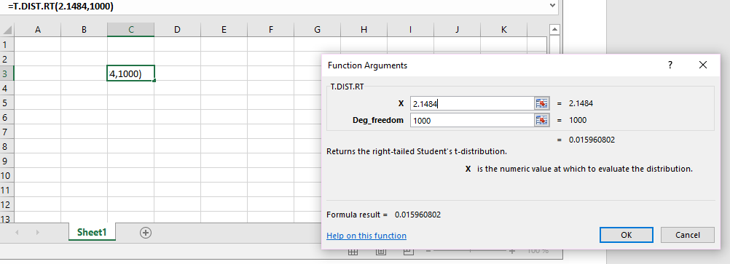
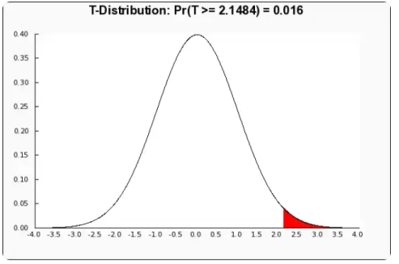
The data is equally distributed about point 0.0. The P-value is less than the significance level, meaning the results are more significant and therefore the null hypothesis is rejected. The smaller the value of P the greater the evidence to reject the null hypothesis.

